20.52: a) 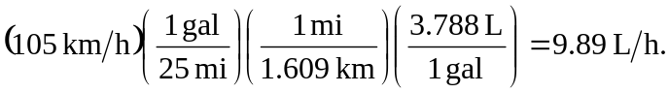

b) From Eq. (20.6),

c) 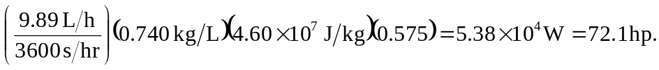

d) Repeating the calculation gives 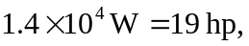about 8% of the maximum power.

